Post-It Poetry
Recommended grade level: 4th and up.
Materials: pads of Post-It notes, pencils, pieces of poster board or cardboard to use as backing boards
Instructions
- Divide students into groups of four or five.
- Invite the group to take a minute to look quietly at the work of art.
- Give each small group a pad of small Post-Its and a backing board.
- Ask students to think of a noun related to the work of art. Have students pass the
Post-It pad around in their group—each group member should write one noun on a Post-It and stick it to the backing board.
- Repeat this process with verbs, adjectives, and, if working with older students, adverbs.
- Have groups trade backing boards. Ask students to, as a group, use the words on the backing boards to create sentences or phrases about the work of art.
- Invite groups to share their creations with the class!
Cross-curricular activity extensions
- Studio Art: Distribute large sheets of paper, and have students use words from their Post-It poems to create a concrete poem that takes the shape of the artwork. If using a sculpture as inspiration, encourage students to sketch the artwork from a variety of angles; to discover different shapes for their poems.
- Foreign Language: Challenge students to complete the activity in a foreign language.
- Language Arts: Invite the groups to label the parts of speech used in their poems.
Question for Reflection
- Have groups compare poems. Return to the artwork to see if the conversation sparked new observations.

DMA Artwork Connection
Dorothea Tanning (American, b. 1910)
Pincushion to Serve as Fetish, 1979
Black velvet, wood, metal, paint, and copper
2005.27 h: 46 1/4”, w: 54 1/8”, d: 48 1/4"
© 1979 Dorothea Tanning / Artists Rights Society (ARS), New York/ADAGP, Paris
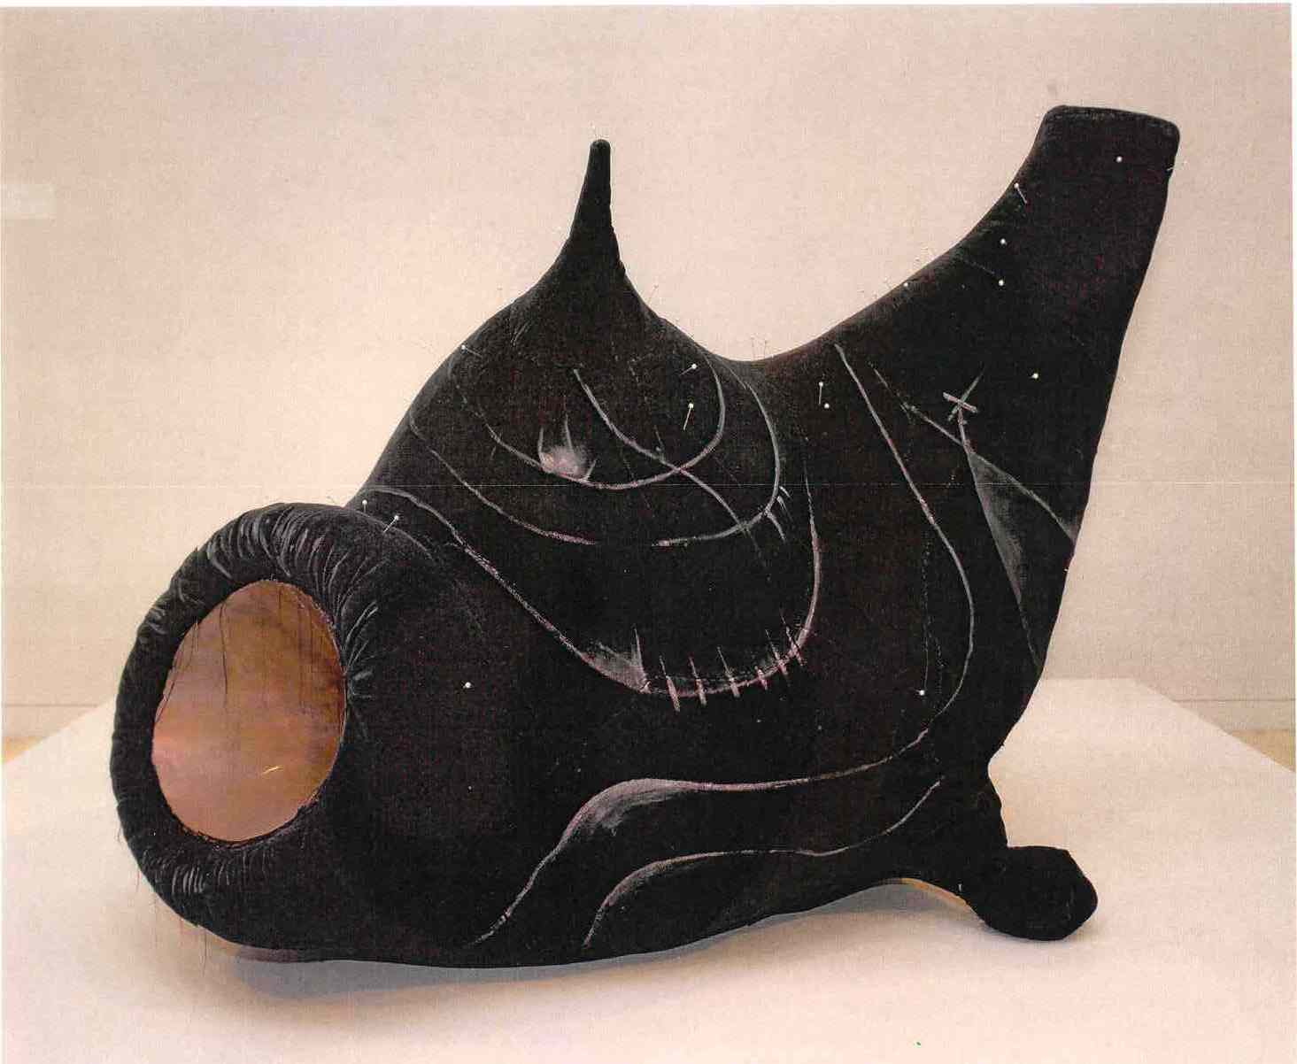
©Dallas Museum of Art, 2010.

