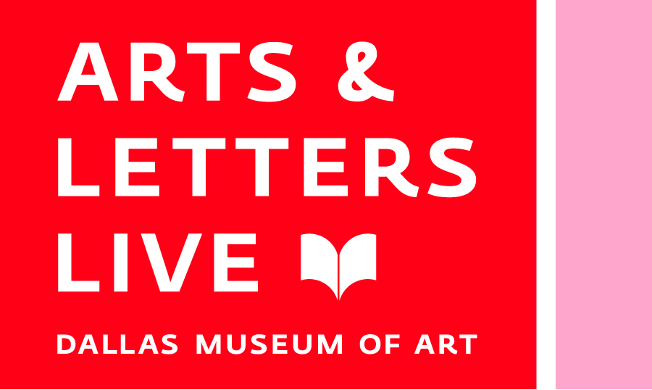
BooksmART
Award-winning authors and illustrators for the young and young-at-heart

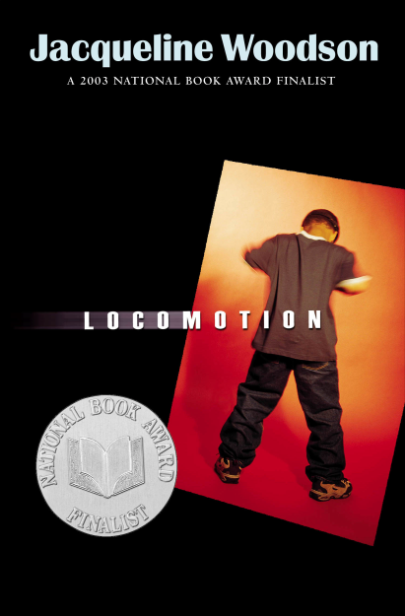
Jacqueline Woodson
Sunday, January 24, Horchow Auditorium, 3:00 p.m.
Jacqueline Woodson has earned a stellar reputation for her award-winning books for children and young adults, including Show Way, Feathers and After Tupac and D. Foster, all three of which received Newbery Honors; Hush, a National Book Award nominee; and Locomotion, a National Book Award finalist. She is also the recipient of the Margaret A. Edwards Award for Lifetime Achievement for the body of her work.

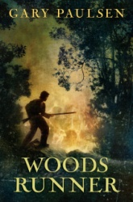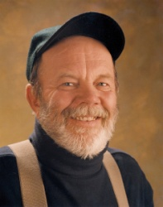

Gary Paulsen
Sunday, February 28, Horchow Auditorium, 3:00 p.m.
With more than 26 million books in print, Gary Paulsen is one of America’s most popular writers for young people. He has won three Newbery Honor Awards for Dogsong, The Winter Room, and Hatchet, which was also named to the School Library Journal list of “One Hundred Books That Shaped the Century.” He will discuss his latest book, Woods Runner, set during the Revolutionary War.

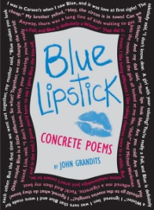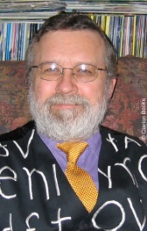

C3 Visiting Artist: Concrete Poet John Grandits

DIY @ DMA: Thursday, March 18, Center for Creative Connections Tech Lab, 6:30 p.m.—8:30 p.m.
Try your hand at concrete poetry inspired by works of art, in which words, ideas, type and art combine to create pictures and patterns.

CONTINUED OVER →
BooksmART
Award-winning authors and illustrators for the young and young-at-heart

C3 Visiting Artist: Concrete Poet John Grandits continued….

Late Nights at the Dallas Museum of Art: Friday, March 19, C3 Theater, 8:30 p.m.—10:00 p.m.
Poet and award-winning book and magazine designer John Grandits will share insights into his creative process, discuss the history of concrete poetry, and help you create your own concrete poems inspired by works of art in the collection.
DIY @ DMA and Late Nights events are free with paid admission to the Museum; all ages welcome.

Young Writers Workshop with John Grandits
Saturday, March 20, Center for Creative Connections Tech Lab,1:00—4:00 p.m.
Teens 13-18 years old who love to write can explore the Museum’s collections and create concrete poems in which words, ideas, type and art combine to create pictures and patterns. Space is limited, registration required. Cost $10.

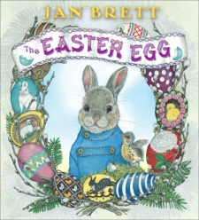

Jan Brett
Sunday, March 28, Horchow Auditorium, 3:00 p.m.
With over thirty-four million books in print, including The Mitten (1989), The Owl and the Pussycat (1991), and The Hat (1997), Jan Brett is one of the nation's foremost author-illustrators of children's books. Her titles are instantly recognizable to children and adults alike, and her exquisitely detailed illustrations bring stories to life for readers of all ages. She will read from her newest book, The Easter Egg.

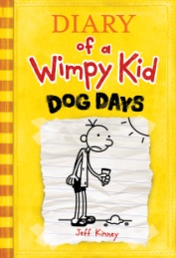

Jeff Kinney
Sunday, April 18, First United Methodist Church of Dallas, 1928 Ross Avenue, 2:00 p.m.
The author of the wildly popular Diary of a Wimpy Kid books, written like pencil-to-paper diary entries by protagonist Greg Heffley, will discuss the series and his inspiration for the books.

Ticket Prices
Full Adult $16
Reduced (Adult DMA members, Educators, Seniors) $14
Student $10
ORDER TICKETS & PRE-PURCHASE BOOKS ONLINE at tickets.DallasMuseumofArt.org or call 214-922-1818 during business hours
For more detailed information visit DallasMuseumofArt.org/ALL

